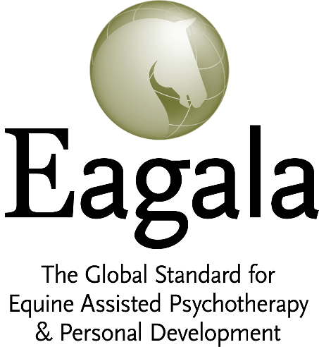

MEMBERS

BRAND STORY

“What lies behind us and what lies before us are tiny matters compared to what lies within us.”

— Ralph Waldo Emerson

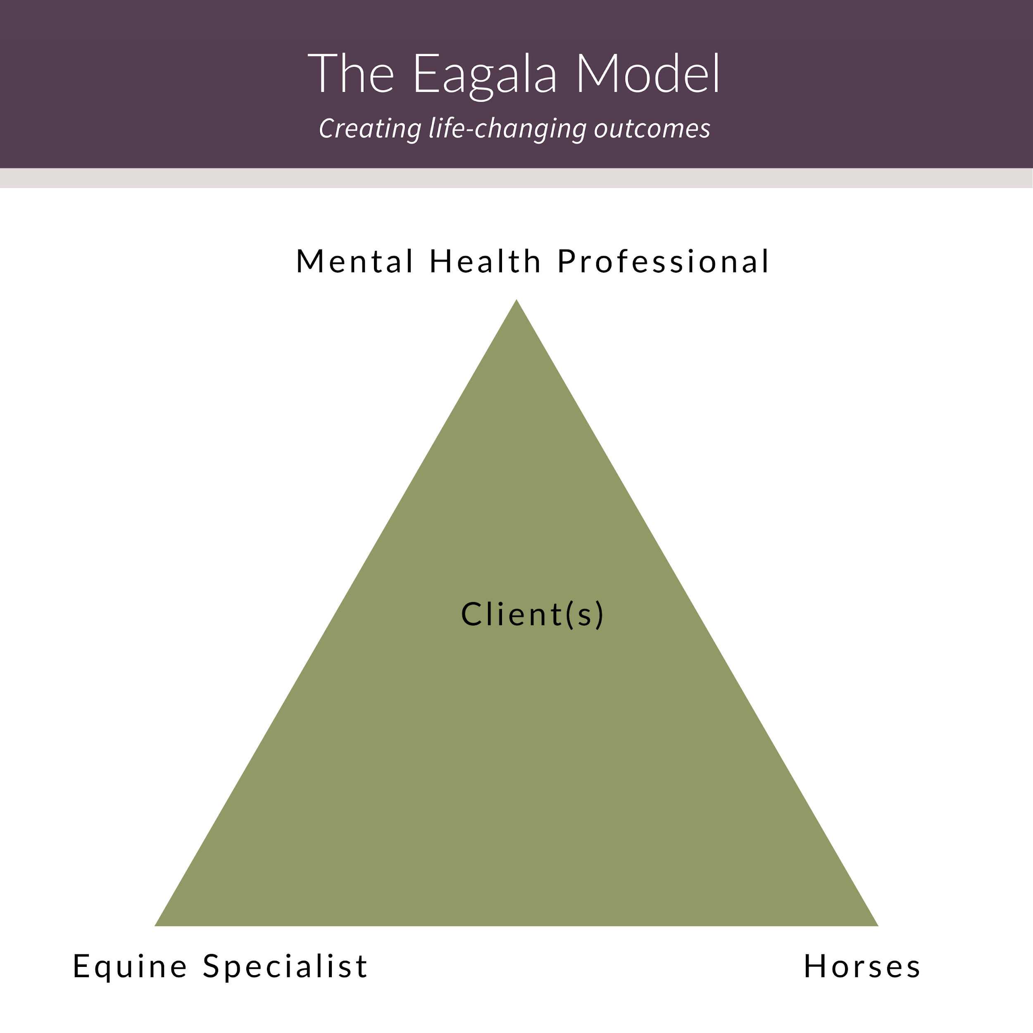

Table of Contents

MEMBER PROGRAM BRAND STORY 5
BRAND PROMISE 5
VALUE PROPOSITION 5
BRAND BOOSTERS 6
YOUR SIGNATURE SYSTEM 6
H.O.R.S.E. - 5 Principles to Life-Changing Outcomes 6
HIGH STANDARDS 6
OUTCOMES 6
REVOLUTIONARY 6
SAFETY 6
EMPOWER 6
YOUR AVATAR - DREAM CLIENT 7
THE GENERAL CLIENT DESCRIPTION 7
GENERAL CLIENT STRUGGLES 8
GENERAL CLIENT DESIRES 8
YOUR POSITIONING 9
YOUR DISTINCTION 9
YOUR SOUL VALUES 9
EAGALA ORGANIZATIONAL BIO 10
KEY MESSAGING 12
SOUL MESSAGE 12
MARKETING MESSAGE 12
TERMS, FORMATS AND TITLES 13
VOCABULARY 14
EAGALA TESTIMONIALS 15
CONTENT LIBRARY - YOUR SIGNATURE SYSTEM 16

MEMBER PROGRAM BRAND STORY

BRAND PROMISE
Brand Promise: The statement that defines your entire business, touching every aspect of your marketing. Choose one and stick to it. Use the others in your marketing for campaign taglines.

Eagala, The Global Standard for Equine-Assisted Psychotherapy and Personal Development

Eagala: A team approach to transforming lives
Life-Changing Outcomes

The Eagala Model
Delivering life-changing outcomes in a safe environment

Eagala, Integrating mental health professionals and equine specialists with horses to benefit people

The Eagala Model works
Helping build a brighter future

VALUE PROPOSITION
Value Proposition: The end-benefit of the service. Attention grabbing and emotive with a brief 2-3 sentence paragraph explaining what you offer, for whom, and why is it useful.

The Eagala Model can change your life. Experience freedom from overwhelming feelings and stress through a new way of treatment incorporating horses. When you feel unable to handle stresses of life and you find yourself in the same situation over and over again, you end up feeling stuck. Emotions and behaviors become problematic and take a toll on relationships and your ability to manage life well. Lacking self-confidence and self-respect, frustrated and discouraged with life, it can seem hopeless. Learn to connect with your self and understand your life story in a non-judgmental and safe space. Explore your struggles and possible solutions through your experience with the horses and guided by your Eagala treatment team. Where traditional therapy leaves off, an Eagala session empowers you to ‘see’ your behaviors and how those behaviors impact you and others. Liberate yourself as you find the answers you are looking for, guided by professionals.

BRAND BOOSTERS
Boosters: Value additions scattered in the copy throughout the site. This list will grow organically. What do you offer that has value to your client beyond the typical? These are elements of your service that are unique and offer more value to your client. Think of your process, and things you may do differently. I.e. a specialized intake process.

- Brilliant customer service and support
- Complimentary remote session
- An informative consent video
- Environment: Is there something special about your environment? For example:
- A beautiful farm in the hills?
- A convenient location in the heart of the city?
- What else is unique about how you provide services?

YOUR SIGNATURE SYSTEM
The structure and organizational way you deliver your expertise, products & services.

H.O.R.S.E. - 5 Principles to Life-Changing Outcomes
for Members to reach out to potential Clients

HIGH STANDARDS

OUTCOMES

REVOLUTIONARY

SAFETY

EMPOWER

YOUR AVATAR - DREAM CLIENT

THE GENERAL CLIENT DESCRIPTION
Your dream client represents the person or groups that are an ideal fit as the people you would most love to work with. And at the same time, you are resonant with them. By identifying this “avatar” of your business goals, you can tailor all of your messaging to speak to this person’s desires. Refer to this section to remain aligned, consistent and attract more of your dream clients.

Fashion these to fit your program, your ideal client attributes.

GENERAL CLIENT DESCRIPTION
For children, adolescents, and adults who are struggling with any variety of behavioral health challenges. They have difficulty with relationships, understanding their emotions and behaviors, and they feel stuck. They are open to new ways of treatment. Often lacking in self-confidence and self-respect, they are earnest and willing to try new ways to feel better in life. They require compassion and a safe space to explore their own inner landscape of emotions and feelings, in a non-judgmental process. Where traditional therapy leaves them frustrated and discouraged, they are seeking an opportunity to ‘see’ their behaviors and how those behaviors impact themselves and others. Eating disorders, ADHD, behavior disorders, depression, anxiety, PTSD are just a few of the emotional/social issues from which they want liberation from.

- Adults suffering from emotional challenges and possible trauma
- Children with a history of trauma
- At-risk adolescents with behavioral problems involving the judicial system
- Military veterans who need help with combat trauma and stress and / or sexual assault
- Adults, corporations, and non-profits who want to expand and grow their personal development and leadership skills
- People who are open to new, innovative ways of treating mental health
- They have a flexible ideology
- Have likely sought help, maybe from multiple sources
- From any economic background
- May have a history of attempted suicide
- May have a criminal record
- Could be at poverty level and be associated with state & government agencies
- May be in foster care and have lived in a toxic environment
- Willing to show up
- Open to new ways of treatment to try new ways to feel better in life
- They require compassion and a safe space to explore their own inner landscape of emotions and beliefs

GENERAL CLIENT STRUGGLES
CLIENT EXTERNAL STRUGGLES
- Overcome by emotions and stressed out in life
- Difficulty with relationships
- Are repeatedly triggered and chastised by those they love
- Lack of self-confidence
- Unable to handle stress well
- Choose alcohol or drugs to cope
- Tired of therapy, waste of time
- Feeling hopeless finding themselves in the same situations over and over again

CLIENT SOULFUL STRUGGLES
- Afraid of losing their family
- Feeling stuck and without hope of getting better
- Struggling to hold it together
- Feel diminished and insignificant
- Suffers from self-doubt and self-loathing
- Frustrated and discouraged, feeling broken and unfixable
- Deeply held feelings such as guilt, loss, depression, or grief run their life

GENERAL CLIENT DESIRES
CLIENT EXTERNAL DESIRES
- To feel liberated from the stronghold of rampant emotions
- To have joyful and safe relationships
- To feel valuable and significant
- To regain control of their lives
- Know how to cope in spite of setbacks and barriers
- To wake up excited about life
- To be confident in their ability to handle life’s challenges
- Ability to express feelings in a healthy way
- Ability to recover from difficult life events
- Ability to bounce back more quickly and with less stress

CLIENT SOULFUL DESIRES
- To come to terms with experiences and injuries
- To make meaning out of their experiences
- To really be healed and able to respond naturally to life
- To feel empowered, seen and heard
- To get help from someone they can trust
- Build strength and resilience
- Learn ways to cope in life

YOUR POSITIONING

YOUR DISTINCTION
A non-traditional team approach that works. Eagala serves a worldwide community of certified professionals and provides a comprehensive certification process and member support network. The treatment team consists of a licensed Mental Health Professional and a qualified Equine Specialist and the horses who work with you. The Eagala program involves no riding, which creates a safe space for you to experience the horses as they relate to your specific and unique challenges. You are guided to listen to your own inner thoughts and feelings while connecting and reflecting on what is happening in the arena. This innovative approach to holding space, and avoiding judgment and interpretation, frees you to discover your own lasting solutions. Giving you innovative methods to empower you and strengthen resiliency.

- Eagala’s philosophy is about holding space, believing in clients and horses, avoiding judgment and interpretation, embracing confidentiality and emotional safety, and mastering skill sets that apply to many areas of life
- The Eagala Model involves no equipment on the horse, and the client never rides the horse
- Innovative approach in our industry - both on the mental health side (incorporating horses) and the equine industry side (no riding, doesn’t look like traditional horsemanship)
- Code of ethics that are honored with values of integrity, innovation and excellence
- Continually improving to keep up with innovations
- High standards and a focus on excellence of training
- Members are supported by a global network of programs, and are continually expanding their skill set and knowledge
- A commitment to making an impact in people’s lives
- An effective and comprehensive model that provides a framework for changing lives
- A reputation of quality, high standards, and professionalism
- The Eagala Model and team approach requires a Mental Health Professional be present
- The Eagala Model involves a specialized skill set, with a team of trained professionals
- Client-centered and solution-oriented - the belief that the best solutions come when one is given the opportunity to discover them
- A dedication to research, outreach and public awareness efforts
- We have sound theoretical foundations to everything we do (not just woo-woo, magic)

YOUR SOUL VALUES
- High Standards
- Outcomes
- Revolutionary
- Safety
- Empower

EAGALA ORGANIZATIONAL BIO
Fashion your own program biography to highlight your distinction in your niche. Paragraphs from the Eagala organizational bio below can be used to highlight points relevant to the audience you are addressing. For example, take the first sentence of the first paragraph, and add one of the other bio paragraphs when addressing military or trauma to focus on the value proposition for that specific psychographic group.

Eagala, the Equine Assisted Growth and Learning Association, was founded in 1999 with the mission to set standards, provide support, and educate professionals who are changing lives through mental health services incorporating horses. Since that time, over 2,500 mental health professionals and equine specialists have been trained and certified, operating over 500 Eagala Model mental health programs in 40 countries. In 2018 alone, these programs served 60,458 clients, confronting challenges such as post-traumatic stress disorder, human trafficking and abuse, addictions, depression, and other behavioral health issues.
Eagala’s military designation further identifies programs with specialized training, cultural competence, and clinical experience working with the military population. Funded through the VA Adaptive Sports Grant, initial data collected through Eagala Model services being provided to veterans by 19 designated programs in the US showed that veterans experienced a clinically meaningful reduction of PTSD symptoms and their quality of life significantly increased.
With the growing mental health needs of individuals, families, and communities, especially during this time of global fear, anxiety, loss, and trauma, Eagala’s services are more important than ever. Eagala’s team approach, integrating mental health professionals, equine specialists, and horses working collaboratively with clients to strengthen resilience and confront challenging mental health issues and stressors, provides a unique, engaging approach that works for many when traditional mental health methods do not. As the leading professional organization for mental health services incorporating horses, Eagala continues to work towards our vision of every person worldwide having access to these life-changing programs.
Because Eagala’s approach incorporates horses, it is especially culturally engaging in agricultural and rural communities where access and stigma for mental health services may still be prevalent, yet the need is still high. The Eagala Model focuses on a strengths-based, client-directed approach. Hands-on experiences with horses are provided which help clients discover their strengths, experience their own solutions, and apply new behaviors, which creates longer-lasting results. With over twenty years in the field, the Eagala Model is tested and subject to ongoing study and development, with a growing body of peer-reviewed evidence supporting its quality of practice, outcomes, and effectiveness. Program results include a much higher rate of engagement where clients start and complete treatment more readily than in traditional office approaches.
Eagala is a registered 501c3 non-profit headquartered in Utah, USA. For more information, visit www.eagala.org
=================================================

EAGALA BOILERPLATE (short version - approximately 100 words)
Fashion your own and use Eagala’s boilerplate as a template.

Eagala, the Equine Assisted Growth and Learning Association, was founded in 1999 with the mission to set standards, provide support, and educate professionals who are changing lives world-wide through mental health services incorporating horses. Over 2,500 mental health professionals and equine specialists have been trained and certified, operating over 500 Eagala Model mental health programs in 40 countries. In 2018 alone, these programs served 60,458 clients, confronting challenges such as post-traumatic stress disorder, human trafficking and abuse, addictions, depression, and other behavioral health issues. Eagala is a registered 501c3 non-profit headquartered in Utah, USA. For more information, visit www.eagala.org

KEY MESSAGING

SOUL MESSAGE
Why you do what you do. What gets you up in the morning as a business owner?

I create positive change in the lives of others all over the world.

MARKETING MESSAGE
These can be interchanged specific to use and audience.

The Eagala Model is a distinctive experiential framework that allows you the latitude to discover, learn, and grow from the horse-human relationship.

The Eagala Model is the global standard for equine-assisted psychotherapy and personal development, which incorporates horses' unique intuition to help you heal, learn and grow.

We provide a revolutionary model that effectively impacts change in your life by incorporating horses into your mental health and personal development sessions.

Eagala is a nonprofit organization that combines mental health professionals, equine specialists and horses, in a mental health model to help improve the lives of people.

Incorporating horses, even with telehealth, we help you deal with overwhelming emotions and come through stronger than ever.

TERMS, FORMATS AND TITLES
USE THESE | DON’T USE THESE
**Equine-assisted Services - only when referring to the industry of all the services (therapy, learning and horsemanship) incorporating horses to benefit people  Otherwise, utilize the terminology specific to our service, i.e. psychotherapy (or mental health or personal development) incorporating horses | Equine assisted/facilitated therapy  Equine therapy  Horse therapy
Eagala  The Eagala Model  Eagala Certified “I am Eagala Certified”  Eagala certification “I have Eagala certification”  client-centered  client-directed  solution-oriented  evidence-driven | client-focused: can be confusing - we don’t focus on the clients
MH  Mental Health Professional (Title Case) | MHP  mental health professional
Incorporating horses  Involving horses | ‘Uses’ horses

VOCABULARY
USE THESE | DON’T USE THESE
Mental Health  Integrity, ethical, safe, clear identity, principles, confidentiality,  excellence, standards, learning, growing, mastery, expertise, skill  collaborate, working together, teamwork, connection, relationship, equals,  innovate, facilitate, improve, discover, revolutionary, natural, story  positive impact, resilience, results, strength, empower, transform  Eagala session, treatment, treatment plan, treatment options, ways, approach, guide, grounded, practical, sensible, designation  unique, distinct, profound, non-traditional, deeper, longer lasting, change, fosters, advances | Therapeutic : Use this term cautiously because it can be associated with non-licensed unprofessional practices

EAGALA TESTIMONIALS
Client Testimonials
As an ongoing best business practice, create a standard process for collecting these valuable testimonials. In them you will find value propositions, feedback from your ideal market as well as soundbites to use in your marketing like on your website. And it keeps you inspired and motivated to read from time to time. These are much more powerful when they come directly from your own clients. If you don’t have testimonials, then consider practice sessions to get them. Download the Eagala Business Jumpstart Toolkit from your My Eagala member area for ways to gather testimonials.
“I’ll never forget my very first session that changed my life forever.” - Lauren N.
“In the six weeks that I did the program, I feel like a completely different person. This has been absolutely the best I’ve experienced with regards to my PTSD.” - Steve S., OEF/OIF Veteran
“The Eagala Model is a kind of catalyst and agent of change during the children’s process. We haven’t found anything else which has achieved better results than these.”
- Administrator at Covenant House, Mexico, on working with human trafficking victims

Model Testimonials by Professionals
“Since embracing the Eagala Model, we are able to get to places in therapy in three or four sessions that used to take us six or eight months. It’s effective and removes a lot of the vulnerabilities inherent with therapy while allowing the emotional process to unfold.” - Andrew Lapin, M.S., M.A.
“The Eagala Model lends itself to transformation in ways that I have not seen before. Participants were able to move through areas of growth with team members so quickly.” - Dawn Wyman, LICSW
“Therapists were surprised at the changes they could see in their clients, several of whom were actively regaining control over their lives.” - Wanda Kay Whittlesey-Jerome, Journal of Counseling and Professional Psychology
“Because of their size, innate and acute sensitivity, and non-verbal nature, horses have a unique appeal helping clients of all ages become more engaged in the psychotherapy process. This form of therapy is especially helpful for children and their families as the horses provide an emotionally safe way to project the strong and difficult feelings stemming from trauma and loss. Trauma is held in the body both physically and emotionally and the horses help healing occur in both these critical areas." - Lynn Thomas, LCSW, Founder & CEO of Eagala

CONTENT LIBRARY - YOUR SIGNATURE SYSTEM
Your content library is informed by your point of view, what you stand for. This answers the second question in brand positioning. It is your overarching viewpoint for how you view the world at large and how you talk about the work that you do. It is used to define the language behind your business and to help illustrate your purpose clearly to others. What you stand for should be infused into every aspect of your communications. In an ideal world, you could remove all elements of visual branding and still know who it is that is speaking.

DOWNLOAD YOUR EAGALA CONTENT LIBRARY FOUND IN YOUR MEMBER RESOURCES

